AUTHOR BIO – Adapted from Wikipedia
George Saunders (aged 59) is an American writer of short stories, essays, novellas, children's books, and novels. Lincoln in the Bardo (Bloomsburry Publishing) won the 2017 Man Booker Prize.
1958 — born December 2nd in Amarillo, Texas. Grew up near Chicago and graduated from high school in Oak Forest, Illinois.

1981 — graduated with a Bachelor of Science in geophysical engineering from Colorado School of Mines in Golden, Colorado.

Of his scientific background, Saunders has said, "...any claim I might make to originality in my fiction is really just the result of this odd background: basically, just me working inefficiently, with flawed tools, in a mode I don't have sufficient background to really understand. Like if you put a welder to designing dresses.”

“I’d been a bad student in high school and now, in engineering school, felt (and was) academically outgunned, way behind the curve. In that state, I constructed a world view in which I was not behind the curve but ahead of it. I conjured up a set of hazy villains, who were, I can see now, externalized manifestations, imaginary versions of those who were leaving me behind; i.e., my better-prepared, more sophisticated fellow-students. They were, yes, smarter and sharper than I was (as indicated by the tests on which they were always creaming me), but I was . . . what was I? Uh, tougher, more resilient, more able to get down and dirty as needed. I distinctly remember the feeling of casting about for some world view in which my shortfall somehow constituted a hidden noble advantage.” (Who Are All These Trump Supporters? July 11 & 18, 2016, The New Yorker magazine)

1988 —graduated with Master’s degree in creative writing from Syracuse University.
- Regarding his influences, Saunders has written: I really love Russian writers, especially from the 19th and early 20th Century: Gogol, Tolstoy, Chekhov, Babel. I love the way they take on the big topics.
- I’m also inspired by a certain absurdist comic tradition that would include influences like Mark Twain, Daniil Kharms, Groucho Marx, Monty Python, Steve Martin, Jack Handey, etc. And then, on top of that, I love the strain of minimalist American fiction writing: Sherwood Anderson, Ernest Hemingway, Raymond Carver, Tobias Wolff.
1989 to 1996 — worked as a technical writer and geophysical engineer for Radian International, an environmental engineering firm in Rochester, New York. Also worked for a time with an oil exploration crew in Sumatra.
1997 — Teaches creative writing in the MFA program at Syracuse University while also publishing fiction and nonfiction.
2006 — Awarded a Guggenheim Fellowship and a $500,000 MacArthur Fellowship.
2007 — Nonfiction collection, The Braindead Megaphone, was published.
2010 — Visiting Writer at Wesleyan University and Hope College and participated in Wesleyan's Distinguished Writers Series and Hope College's Visiting Writers Series.
His writing has appeared in The New Yorker, Harper's, McSweeney's, and GQ. He also contributed a weekly column, American Psyche, to the weekend magazine of The Guardian between 2006 and 2008.

From Showers of Hats, Robert Baird
In the early part of his career, Saunders was celebrated mostly as a satirist. He trained as a petrochemical engineer, and wrote his earliest published stories while working as a technical writer in upstate New York. The experience left him on intimate terms with the microhumiliations of white-collar drudge work. Years before The Office mined the same seam, Saunders identified the specific perversity of the modern corporation, which demands not just work from its employees but loyalty and affection – even something like love. Unlike Ricky Gervais, however, who hitched his on-screen satires to a realistic setting, Saunders translated his stories out into the near future, or over into cockeyed alternative versions of the present. His stories were filled with perverted theme parks, creepy testing facilities and grungy sci-fi conceits, all rendered in a hypercolloquial idiolect that set the chipper barbarities of capitalism in scathing relief.
When CivilWarLand appeared, in the mid-1990s, it was quickly swept up into one of America’s rare and mysterious revolutions in sentiment. A broad insurgency of irony was rising up in just about every medium – The Simpsons, the Baffler, Pulp Fiction – against the schmaltz that had ruled the country’s mass culture for decades. But even then it was obvious that Saunders wasn’t interested in snark for snark’s sake. Jay McInerney, reviewing CivilWarLand for the New York Times, recognised him as ‘one of those rare writers who can effortlessly blend satire and sentiment’. The shape of that sentiment became increasingly clear. In a eulogy for David Foster Wallace, who killed himself in 2008, Saunders explained his friend’s accomplishment in terms that made it hard not to imagine he was also describing his own aspirations: ‘Something about the prose itself was inducing a special variety of openness that I might call terrified-tenderness: a sudden new awareness of what a fix we’re in on this earth, stuck in these bodies, with these minds.’ To say that Saunders sought empathy in a world that seemed hostile to it wasn’t to say that he went in for easy uplift and happy endings: the poor in his stories got poorer, the cruelties of the universe were compounded, and not even death offered much of a reprieve. Many of his protagonists aren’t kind or even objectively decent human beings, but they are, in a strict sense, sympathetic: Saunders lets us overhear their rationalisations, their excuses, the stories they tell themselves to live. The goal, as he described it in an interview last year, was to create ‘a space the reader and writer agree to participate in together, within the playing field of a work of prose – in which they agree to make up a person and, together, go: “What would it be like to be her? How does she think? From what valid impulse do her mistakes stem?”’
In retrospect, the most striking thing about this focus on compassion was the way it accompanied – and even hastened – a growing consensus in American literary circles that saw empathy as fiction’s remaining credible raison d’être. For Saunders, as for Wallace, fiction’s task among the arts was to offer an answer to the problem of other minds. ‘The prime quality of literary prose – that is, the thing it does better than any other form (movies, songs, sculpture, tweets, television, you name it) – is voice,’ Saunders wrote recently. ‘A great writer mimicking, on the page, the dynamic energy of human thought is about as close as we can get to modelling pure empathy.’ Saunders’s reputation grew to the point that in 2013 a profile in the New York Times Magazine called him ‘a kind of superhero’. What was surprising wasn’t so much the suggestion that he was ‘the writer for our time’ – it would be hard to overstate his influence on American writing – but the terms on which the claim was established. According to the profile, Saunders had ascended to the first rank of American fiction because he helped his readers be ‘wiser, better, more disciplined in [their] openness to the experience of other people’.

Additional Awards

1994 —National Magazine Award for Fiction – "The 400-Pound CEO", short story published in Harper's Magazine
- 1996 — National Magazine Award for Fiction – "Bounty", short story, published in Harper's Magazine
- 1997 — 2nd Prize in the O. Henry Awards – "The Falls", short story, published in The New Yorker (January 22, 1996 issue)
- 2000 — National Magazine Award for Fiction – "The Barber's Unhappiness", short story, published in The New Yorker
- 2001 — Lannan Foundation – Lannan Literary Fellowship
- 2004 — National Magazine Award for Fiction – "The Red Bow", short story published in Esquire
- 2005 — World Fantasy Award for Best Short Story – "CommComm", published in The New Yorker August 1, 2005
- 2009 — American Academy of Arts and Letters, Academy Award
- 2013 — PEN/Malamud Award for Excellence in the Short Story
- 2013 — The Story Prize – Tenth of December: Stories
- 2013 —The New York Times Book Review, "10 Best Books of 2013", Tenth of December: Stories
- 2014 — Folio Prize – Tenth of December: Stories
- 2014 — American Academy of Arts and Sciences, Elected as Member,
- 2018 — American Academy of Arts and Letters, Inducted as Member
Finalist Honors
- 1996 — PEN/Hemingway Award – Finalist – CivilWarLand in Bad Decline
- 2006 —The Story Prize – Finalist – In Persuasion Nation
- 2011 —Bram Stoker Award – Finalist – "Home" (short story
- 2014 —National Book Award for Fiction – Finalist – Tenth of December: Stories

Personal life
- Married to Paula Redick, also a writer and they have two daughters, Caitlin and Alena.
- Saunders considered himself an Objectivist in his twenties but now views it unfavorably, likening it to neoconservatism.
[Wikipedia: Objectivism's central tenets are that reality exists independently of consciousness, that human beings have direct contact with reality through sense perception, that one can attain objective knowledge from perception through the process of concept formation and inductive logic, that the proper moral purpose of one's life is the pursuit of one's own happiness (rational self-interest), that the only social system consistent with this morality is one that displays full respect for individual rights embodied in laissez-faire capitalism, and that the role of art in human life is to transform humans' metaphysical ideas by selective reproduction of reality into a physical form—a work of art—that one can comprehend and to which one can respond emotionally.
Academic philosophers have mostly ignored or rejected Rand's philosophy. Nonetheless, Objectivism has been a significant influence among libertarians and American conservatives. The Objectivist movement, which Rand founded, attempts to spread her ideas to the public and in academic settings.]
- He is now a student of Nyingma Buddhism, the oldest of the four major schools of Tibetan Buddhism.

Convocation speech delivered at Syracuse University for the class of 2013, published on the website of the New York Times Times — https://www.youtube.com/watch?v=ruJWd_m-LgY

“Down through the ages, a traditional form has evolved for this type of speech, which is: Some old fart, his best years behind him, who, over the course of his life, has made a series of dreadful mistakes (that would be me), gives heartfelt advice to a group of shining, energetic young people, with all of their best years ahead of them (that would be you).
And I intend to respect that tradition.
Now, one useful thing you can do with an old person, in addition to borrowing money from them, or asking them to do one of their old-time “dances,” so you can watch, while laughing, is ask: “Looking back, what do you regret?” And they’ll tell you. Sometimes, as you know, they’ll tell you even if you haven’t asked. Sometimes, even when you’ve specifically requested they not tell you, they’ll tell you.
So: What do I regret? Being poor from time to time? Not really. Working terrible jobs, like “knuckle-puller in a slaughterhouse?” (And don’t even ASK what that entails.) No. I don’t regret that. Skinny-dipping in a river in Sumatra, a little buzzed, and looking up and seeing like 300 monkeys sitting on a pipeline, pooping down into the river, the river in which I was swimming, with my mouth open, naked? And getting deathly ill afterwards, and staying sick for the next seven months? Not so much. Do I regret the occasional humiliation? Like once, playing hockey in front of a big crowd, including this girl I really liked, I somehow managed, while falling and emitting this weird whooping noise, to score on my own goalie, while also sending my stick flying into the crowd, nearly hitting that girl? No. I don’t even regret that.
But here’s something I do regret:
In seventh grade, this new kid joined our class. In the interest of confidentiality, her Convocation Speech name will be “ELLEN.” ELLEN was small, shy. She wore these blue cat’s-eye glasses that, at the time, only old ladies wore. When nervous, which was pretty much always, she had a habit of taking a strand of hair into her mouth and chewing on it.
So she came to our school and our neighborhood, and was mostly ignored, occasionally teased (“Your hair taste good?” — that sort of thing). I could see this hurt her. I still remember the way she’d look after such an insult: eyes cast down, a little gut-kicked, as if, having just been reminded of her place in things, she was trying, as much as possible, to disappear. After awhile she’d drift away, hair-strand still in her mouth. At home, I imagined, after school, her mother would say, you know: “How was your day, sweetie?” and she’d say, “Oh, fine.” And her mother would say, “Making any friends?” and she’d go, “Sure, lots.”
Sometimes I’d see her hanging around alone in her front yard, as if afraid to leave it.
And then — they moved. That was it. No tragedy, no big final hazing.
One day she was there, next day she wasn’t.
End of story.
Now, why do I regret that? Why, forty-two years later, am I still thinking about it? Relative to most of the other kids, I was actually pretty nice to her. I never said an unkind word to her. In fact, I sometimes even (mildly) defended her.
But still. It bothers me.
So here’s something I know to be true, although it’s a little corny, and I don’t quite know what to do with it:
What I regret most in my life are failures of kindness.
Those moments when another human being was there, in front of me, suffering, and I responded … sensibly. Reservedly. Mildly.
Or, to look at it from the other end of the telescope: Who, in your life, do you remember most fondly, with the most undeniable feelings of warmth?
Those who were kindest to you, I bet.
It’s a little facile, maybe, and certainly hard to implement, but I’d say, as a goal in life, you could do worse than: Try to be kinder.
Now, the million-dollar question: What’s our problem? Why aren’t we kinder?
Here’s what I think:
Each of us is born with a series of built-in confusions that are probably somehow Darwinian. These are: (1) we’re central to the universe (that is, our personal story is the main and most interesting story, the only story, really); (2) we’re separate from the universe (there’s US and then, out there, all that other junk – dogs and swing-sets, and the State of Nebraska and low-hanging clouds and, you know, other people), and (3) we’re permanent (death is real, o.k., sure – for you, but not for me).
Now, we don’t really believe these things – intellectually we know better – but we believe them viscerally, and live by them, and they cause us to prioritize our own needs over the needs of others, even though what we really want, in our hearts, is to be less selfish, more aware of what’s actually happening in the present moment, more open, and more loving.
So, the second million-dollar question: How might we DO this? How might we become more loving, more open, less selfish, more present, less delusional, etc., etc?
Well, yes, good question.
Unfortunately, I only have three minutes left.
So let me just say this. There are ways. You already know that because, in your life, there have been High Kindness periods and Low Kindness periods, and you know what inclined you toward the former and away from the latter. Education is good; immersing ourselves in a work of art: good; prayer is good; meditation’s good; a frank talk with a dear friend; establishing ourselves in some kind of spiritual tradition — recognizing that there have been countless really smart people before us who have asked these same questions and left behind answers for us.
Because kindness, it turns out, is hard — it starts out all rainbows and puppy dogs, and expands to include . . . well, everything.
One thing in our favor: some of this “becoming kinder” happens naturally, with age. It might be a simple matter of attrition: as we get older, we come to see how useless it is to be selfish — how illogical, really. We come to love other people and are thereby counter-instructed in our own centrality. We get our butts kicked by real life, and people come to our defense, and help us, and we learn that we’re not separate, and don’t want to be. We see people near and dear to us dropping away, and are gradually convinced that maybe we too will drop away (someday, a long time from now). Most people, as they age, become less selfish and more loving. I think this is true. The great Syracuse poet, Hayden Carruth, said, in a poem written near the end of his life, that he was “mostly Love, now.”
And so, a prediction, and my heartfelt wish for you: as you get older, your self will diminish and you will grow in love. YOU will gradually be replaced by LOVE. If you have kids, that will be a huge moment in your process of self-diminishment. You really won’t care what happens to YOU, as long as they benefit. That’s one reason your parents are so proud and happy today. One of their fondest dreams has come true: you have accomplished something difficult and tangible that has enlarged you as a person and will make your life better, from here on in, forever.
Congratulations, by the way.
When young, we’re anxious — understandably — to find out if we’ve got what it takes. Can we succeed? Can we build a viable life for ourselves? But you — in particular you, of this generation — may have noticed a certain cyclical quality to ambition. You do well in high-school, in hopes of getting into a good college, so you can do well in the good college, in the hopes of getting a good job, so you can do well in the good job so you can . . .
And this is actually O.K. If we’re going to become kinder, that process has to include taking ourselves seriously — as doers, as accomplishers, as dreamers. We have to do that, to be our best selves.
Still, accomplishment is unreliable. “Succeeding,” whatever that might mean to you, is hard, and the need to do so constantly renews itself (success is like a mountain that keeps growing ahead of you as you hike it), and there’s the very real danger that “succeeding” will take up your whole life, while the big questions go untended.
So, quick, end-of-speech advice: Since, according to me, your life is going to be a gradual process of becoming kinder and more loving: Hurry up. Speed it along. Start right now. There’s a confusion in each of us, a sickness, really: selfishness. But there’s also a cure. So be a good and proactive and even somewhat desperate patient on your own behalf — seek out the most efficacious anti-selfishness medicines, energetically, for the rest of your life.
Do all the other things, the ambitious things — travel, get rich, get famous, innovate, lead, fall in love, make and lose fortunes, swim naked in wild jungle rivers (after first having it tested for monkey poop) – but as you do, to the extent that you can, err in the direction of kindness. Do those things that incline you toward the big questions, and avoid the things that would reduce you and make you trivial. That luminous part of you that exists beyond personality — your soul, if you will — is as bright and shining as any that has ever been. Bright as Shakespeare’s, bright as Gandhi’s, bright as Mother Teresa’s. Clear away everything that keeps you separate from this secret luminous place. Believe it exists, come to know it better, nurture it, share its fruits tirelessly.
And someday, in 80 years, when you’re 100, and I’m 134, and we’re both so kind and loving we’re nearly unbearable, drop me a line, let me know how your life has been. I hope you will say: It has been so wonderful.
Congratulations, Class of 2013.
I wish you great happiness, all the luck in the world, and a beautiful summer.

RESEARCH
Abraham Lincoln Timeline — http://www.historyplace.com/lincoln/index.html
1637 - Samuel Lincoln from Hingham, England, settles in Hingham, Massachusetts.
1778 - Thomas Lincoln (Abraham's father), descendant of Samuel, is born in Virginia.
1782 - Thomas and family move to Kentucky.
1786 - Thomas' father is killed by Native Americans.
1806 - Thomas marries Nancy Hanks. A daughter, Sarah, is born eight months later.
1808 - Thomas buys a farm called "Sinking Spring" near Hodgenville, Kentucky.
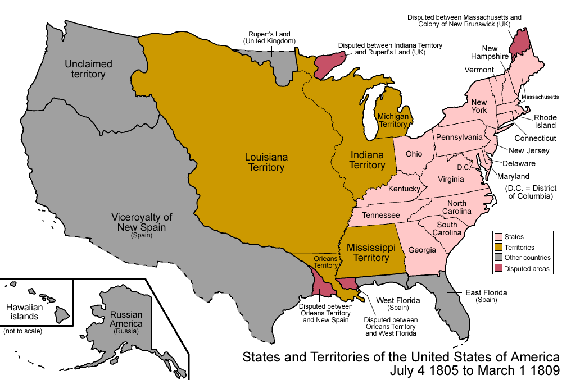
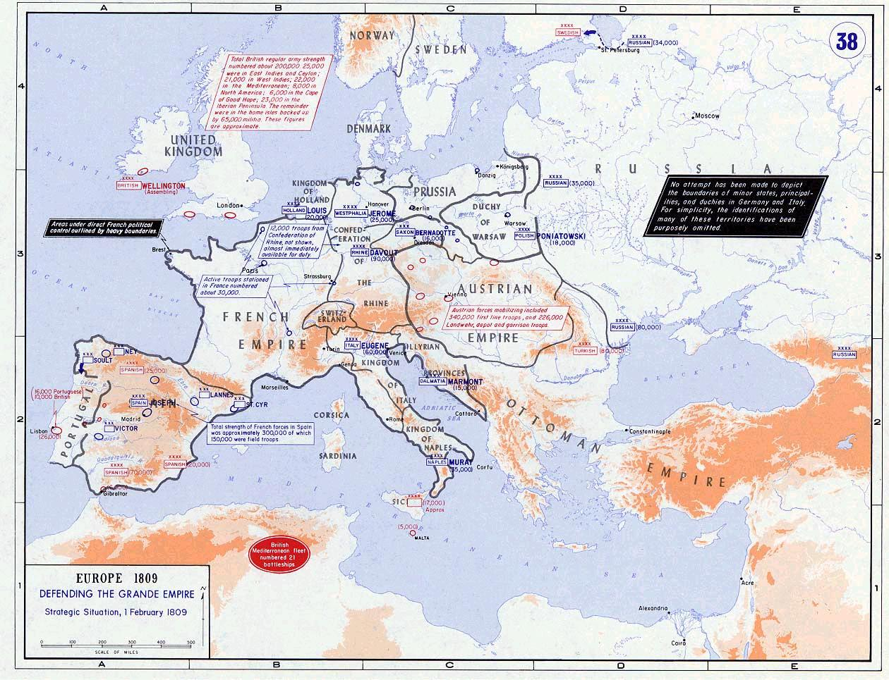
February 12, 1809 - Abraham Lincoln is born in a one-room log cabin on Nolin Creek in Kentucky.
1811 - In spring, the Lincoln family moves to a 230-acre farm on Knob Creek ten miles from Sinking Spring.
1812 - A brother, Thomas, is born but dies in infancy.
1815 - Young Abraham attends a log school house.
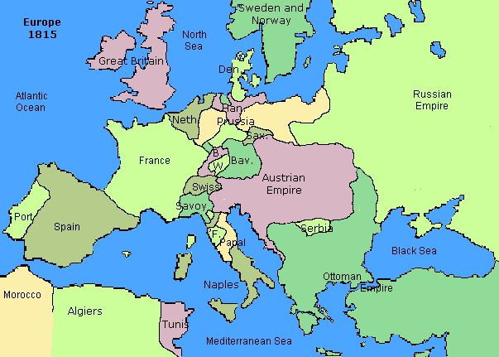
1816 - Abraham briefly attends school. In December, the Lincoln family crosses the Ohio River and settles in the backwoods of Indiana.
1817 - In February, Abraham, age 7, shoots a wild turkey but suffers great remorse and never hunts game again.
1818 - Young Abraham is kicked in the head by a horse and for a brief time is thought to be dead. On October 5th, Nancy Hanks Lincoln (his mother) dies of "milk sickness."
1819 - On December 2nd, Abraham's father, Thomas, marries a widow, Sarah Bush Johnston, and becomes stepfather to her three children. Abraham develops much affection for his stepmother.
1820 - Abraham, now 11, briefly attends school.
1822 - Abraham attends school for a few months.
1824 - Abraham, now 15, and called 'Abe' by his friends, does plowing and planting and work-for-hire for neighbors. He attends school in the fall and winter, also borrows books and reads whenever possible.
1828 - On January 20th, his married sister, Sarah, dies while giving birth. In April, Abe, now 19, and Allen Gentry take a flatboat containing a cargo of farm produce to New Orleans. During the trip they fight off a robbery attack by seven black men. At New Orleans, Abe observes a slave auction.
1830 - In March, Abe and his family begin a 200-mile journey to Illinois where they settle on uncleared land along the Sangamon River, near Decatur. Abe makes his first-ever political speech in favor of improving navigation on the Sangamon River.
1831 - Abe makes a second flatboat trip to New Orleans. His father moves again, but Abe doesn't go and instead settles in New Salem, Illinois, where he works as a clerk in the village store and sleeps in the back. During this year, he wrestles a man named Jack Armstrong to a draw. He learns basic math, reads Shakespeare and Robert Burns and also participates in a local debating society.
1832 - In March, Abraham Lincoln becomes a candidate for the Illinois General Assembly. The Black Hawk War breaks out. In April, Abe enlists and is elected captain of his rifle company. He re-enlists as a private after his company is disbanded. He serves a total of three months but does not fight in a battle. On August 6th, he loses the election for General Assembly. The village store he worked in goes out of business. Lincoln and partner, William Berry, purchase another village store in New Salem.
1833 - The new store fails, leaving Abe badly in debt. Lincoln is then appointed Postmaster of New Salem. In autumn, Lincoln is appointed Deputy County Surveyor.
1834 - On August 4th, Abraham Lincoln, age 24, is elected to the Illinois General Assembly as a member of the Whig Party. He begins to study law. In December, he first meets Stephen A. Douglas, 21, a Democrat.
1835 - In January, former store partner William Berry dies, increasing Lincoln's debt to $1,000. On August 25th, Ann Rutledge, Lincoln's love interest, dies from fever at age 22.
1836 - On August 1st, Lincoln is re-elected to the Illinois General Assembly and by now is a leader of the Whig Party. September 9th, Lincoln receives his license to practice Law. He begins a courtship of Mary Owens, 28. He suffers an episode of severe depression in December.
1837 - Lincoln helps to get the Illinois state capital moved from Vandalia to Springfield. On April 15th, he leaves New Salem and settles in Springfield, then becomes a law partner of John T. Stuart. In the summer, Abe proposes marriage to Mary Owens, but is turned down and the courtship ends.
1838 - Lincoln helps to successfully defend Henry Truett in a famous murder case. On August 6th, he is re-elected to the Illinois General Assembly, becoming Whig Floor Leader.
1839 - Abe travels through nine counties in central and eastern Illinois as a lawyer on the 8th Judicial Circuit. On December 3rd, he is admitted to practice in the United States Circuit Court. He meets Mary Todd, 21, at a dance.
1840 - In June, Lincoln argues his first case before the Illinois Supreme Court. On August 3rd, he is re-elected to the Illinois General Assembly. In autumn, he becomes engaged to Mary Todd.
1841 - January 1st, Abe breaks off the engagement with Mary Todd. He has another episode of depression. On March 1st, he forms a new law partnership with Stephen T. Logan. In August, Abe makes a trip by steamboat to Kentucky and observes twelve slaves chained together.
1842 - Lincoln does not seek re-election to the legislature. In the summer, he resumes his courtship with Mary Todd. In September, Abe accepts a challenge to a duel by Democratic state auditor James Shields over published letters making fun of Shields. On September 22nd, the duel with swords is averted by an explanation of letters. On November 4th, Abraham Lincoln (age 33) marries Mary Todd (age 24) in Springfield.
1843 - Lincoln is unsuccessful in his try for the Whig nomination for U.S. Congress. On August 1st, his first child, Robert Todd Lincoln, is born.
1844 - In May, the Lincoln family moves into a house in Springfield, Illinois, bought for $1,500. Abe campaigns for Henry Clay in the presidential election. In December, he dissolves his law partnership with Logan, then sets up his own practice.
1846 - March 10th, a son, Edward Baker Lincoln is born. On May 1st, Abe is nominated to be the Whig candidate for U.S. Congress. On August 3rd, Abraham Lincoln is elected to the U.S. House of Representatives.
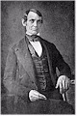First known photograph of Lincoln, about 1846
1847 - U.S. Representative Lincoln moves into a boarding house in Washington, D.C., with his wife and two sons. On December 6th, he takes his seat when the Thirtieth Congress convenes. December 22nd, Rep. Lincoln presents resolutions questioning President Polk about U.S. hostilities with Mexico.
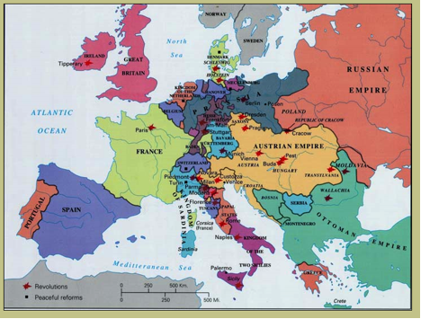
1848 - On January 22nd, Rep. Lincoln gives a speech on floor of the House against President Polk's war policy regarding Mexico. In June, he attends the national Whig convention, supporting General Zachary Taylor as the nominee for president. He campaigns for Taylor in Maryland and in Boston, Massachusetts, then in Illinois.
1849 - March 7th and 8th, Lincoln makes an appeal before the U.S. Supreme Court regarding the Illinois statute of limitations, but is unsuccessful. On March 31st, he returns to Springfield and leaves politics to practice law. On May 22nd, Abraham Lincoln is granted U.S. Patent No. 6,469 (the only President ever granted a patent).
1850 - February 1st, his three-year-old son Edward dies after a two-month illness. Lincoln resumes his travels in the 8th Judicial Circuit covering over 400 miles in 14 counties in Illinois. "Honest Abe," as he is called, earns a reputation as an outstanding lawyer. On December 21st, another son, William Wallace Lincoln (Willie) is born.
1851 - January 17th, Lincoln's father dies.
1853 - On April 4th, his fourth son, Thomas (Tad) Lincoln is born.
1854 - Lincoln re-enters politics, opposing the Kansas-Nebraska Act. He is elected to the Illinois legislature but declines the seat, hoping instead to become a U.S. Senator (appointed by the legislature).
1855 - Lincoln does not get chosen by the Illinois legislature to be U.S. Senator.
1856 - May 29th, Lincoln helps organize the new Republican Party of Illinois. At the first Republican convention, Lincoln gets 110 votes for the vice-presidential nomination, thereby gaining national attention. He campaigns in Illinois for the Republican presidential candidate, John C. Frémont.
1857 - On June 26th, in Springfield, Lincoln speaks against the Dred Scott Decision.
1858 - In May, Lincoln wins acquittal in a murder trial by using an almanac regarding the height of the moon to discredit a key witness. On June 16th, he is nominated to be the Republican Senator from Illinois, opposing Democrat Stephen A. Douglas. He gives his "House Divided" speech at the state convention in Springfield. He also engages Douglas in seven separate debates, attracting big audiences at each one.
1859 - The Illinois legislature chooses Douglas for the U.S. Senate over Lincoln by a vote of 54 to 46. In autumn, Lincoln makes his last trip through the 8th Judicial Circuit. On December 20th, writes a short autobiography.
1860 - March 6th, Lincoln delivers an impassioned speech on slavery in New Haven, Connecticut. Also in March, the "Lincoln-Douglas Debates" are published.
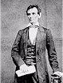Nominee for president - 1860
May 18, 1860 - Abraham Lincoln (age 51) is nominated to be the Republican candidate for President of the United States. He opposes Northern Democrat, Stephen A. Douglas, and Southern Democrat, John C. Breckinridge. In June, he writes a longer autobiography.
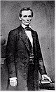The first portrait by Mathew Brady - February, 1860
November 6, 1860 - Abraham Lincoln is elected as 16th President of the United States, and is the first Republican. He receives 180 of 303 possible electoral votes and 40 percent of the popular vote.
December 20, 1860 - South Carolina secedes from the Union – followed within two months by Mississippi, Florida, Alabama, Georgia, Louisiana and Texas.

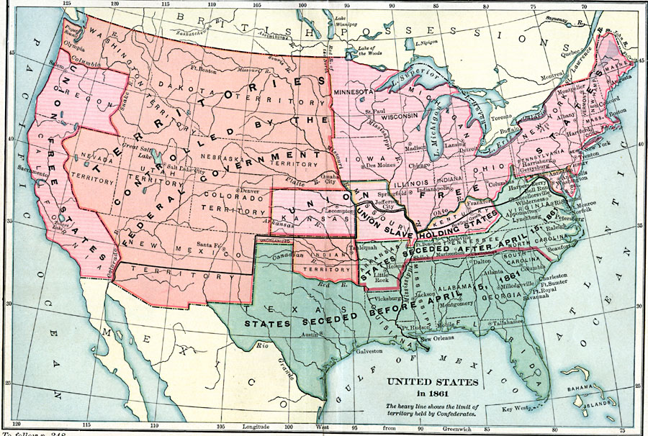
February 11, 1861 - President-elect Lincoln gives a brief farewell to friends and supporters at Springfield and leaves by train for Washington, D.C. During the train trip, he is warned about a possible assassination attempt.
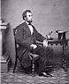President-elect Lincoln - February 23, 1861
March 4, 1861 - Inauguration ceremonies are held in Washington, D.C. President Lincoln delivers his First Inaugural Address.
April 12, 1861 - At 4:30 a.m., Confederate artillery opens fire on Fort Sumter in Charleston Harbor. The Civil War begins.
* * * * *
April 15, 1861 - President Lincoln issues a Proclamation Calling Militia and Convening Congress.
April 17, 1861 - Virginia secedes from the Union – followed within five weeks by North Carolina, Tennessee and Arkansas, thus forming an eleven-state Confederacy.
April 19, 1861 - The President issues a Proclamation of Blockade against Southern ports.
April 27, 1861 - The President authorizes the suspension of the Writ of Habeas Corpus.
June 3, 1861 - Political rival Stephen A. Douglas dies unexpectedly of acute rheumatism.
July 21, 1861 - The Union suffers a defeat at Bull Run in northern Virginia. Union troops fall back to Washington. The President now realizes the war will be long.
July 27, 1861 - Lincoln appoints George B. McClellan as Commander of the Department of the Potomac.
August 6, 1861 - Signs a law freeing slaves being used by the Confederates in their war effort.
August 12, 1861 - The President issues a Proclamation of a National Day of Fasting.
September 11, 1861 - Revokes General John C. Frémont's unauthorized military proclamation of emancipation in Missouri.
October 24, 1861 - Relieves General Frémont of his command and replaces him with General David Hunter.
November 1, 1861 - Appoints General McClellan as Commander of the Union Army after the resignation of Winfield Scott.
January 27, 1862 - Issues General War Order No. 1 calling for a Union advance to begin February 22nd.
February 3, 1862 - Writes a message to McClellan on a difference of opinion regarding military plans.
February 20, 1862 - The President's son Willie dies at age 11. The President's wife is emotionally devastated and never fully recovers.
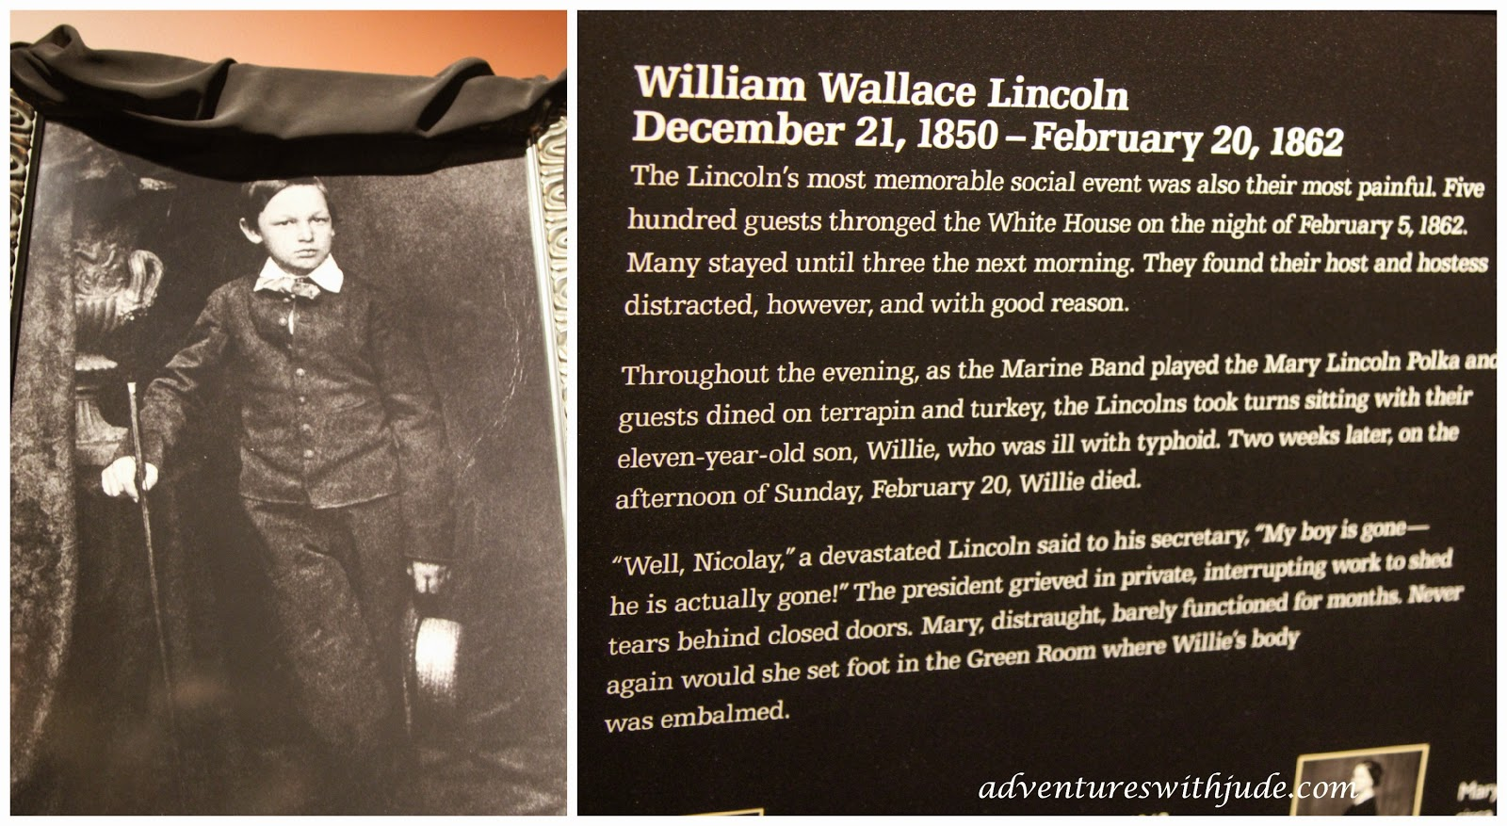

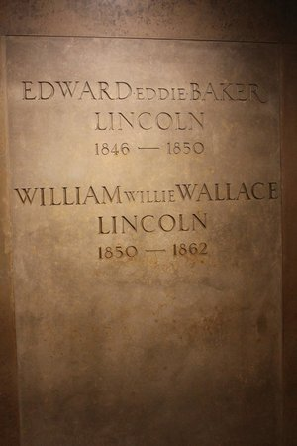
March 11, 1862 - President Lincoln relieves McClellan as General-in-Chief and takes direct command of the Union armies.
April 6, 1862 - A Confederate surprise attack on General Ulysses S. Grant's troops at Shiloh on the Tennessee River results in a bitter struggle with 13,000 Union men killed and wounded and 10,000 Confederates. The President is then pressured to relieve Grant but resists.
April 9, 1862 - Writes a message to McClellan urging him to attack.
April 16, 1862 - Signs an Act abolishing slavery in the District of Columbia.
May 20, 1862 - Approves the Federal Homestead Law giving 160 acres of publicly owned land to anyone who will claim and then work the property for 5 years. Thousands then cross the Mississippi to tame the 'Wild West.'
June 19, 1862 - Approves a Law prohibiting slavery in the Territories.
August 29/30, 1862 - The Union suffers a defeat at the second Battle of Bull Run in northern Virginia. The Union Army retreats to Washington, D.C. The President then relieves Union Commander, General John Pope.
September 17, 1862 - General Robert E. Lee and the Confederate armies are stopped at Antietam in Maryland by McClellan and his numerically superior Union forces. By nightfall, 26,000 men are dead, wounded or missing - the bloodiest day in U.S. military history.
September 22, 1862 - The President issues a preliminary Emancipation Proclamation freeing the slaves.
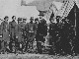Visiting General George McClellan, Antietam, Maryland - 1862
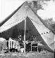In General McClellan's tent - October 3, 1862
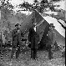With Allan Pinkerton and Major General McClernand - October 1862
November 5, 1862 - The President names Ambrose E. Burnside as Commander of the Army of the Potomac, replacing McClellan.
December 13, 1862 - The Army of the Potomac suffers a costly defeat at Fredericksburg in Virginia with a loss of 12,653 men. Confederate losses are 5,309.
December 22, 1862 - The President writes a brief message to the Army of the Potomac.
December 31, 1862 - The President signs a bill admitting West Virginia to the Union.
January 1, 1863 - President Lincoln issues the final Emancipation Proclamation freeing all slaves in territories held by Confederates.
January 25, 1863 - The President appoints Joseph (Fighting Joe) Hooker as Commander of the Army of the Potomac, replacing Burnside.
January 26, 1863 - Writes a message to Hooker.
January 29, 1863 - General Ulysses S. Grant is placed in command of the Army of the West, with orders to capture Vicksburg.
February 25, 1863 - Signs a Bill creating a National banking system.
March 3, 1863 - Signs an Act introducing military conscription.
May 1-4, 1863 - The Union suffers a defeat in the Battle of Chancellorsville in Virginia. Famed Confederate General Stonewall Jackson is mortally wounded. Hooker retreats. Union losses are 17,000 killed, wounded and missing. Confederate losses are 13,000.
June 28, 1863 - The President appoints George G. Meade as Commander of the Army of the Potomac, replacing Hooker.
July 3, 1863 - Confederate defeat in the Battle of Gettysburg marks the turning point of the war.
See photographs taken just after the Battle
July 4, 1863 - Vicksburg, the last Confederate stronghold on the Mississippi, is captured by the General Grant and the Army of the West.
July 13, 1863 - The President writes a message to Grant.
July 14, 1863 - Writes an undelivered letter to Meade complaining about his failure to capture Lee.
July 30, 1863 - Issues an Order of Retaliation.
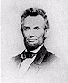1863 portrait by Brady
August 8, 1863 - Writes a letter to his wife regarding their son Tad's lost goat.
August 10, 1863 - The President meets with abolitionist Frederick Douglass who pushes for full equality for Union 'Negro troops.'
September 19/20, 1863 - A Union defeat at Chickamauga in Georgia leaves Chattanooga in Tennessee under Confederate siege. The President appoints General Grant to command all operations in the Western Theater.
October 3, 1863 - Issues a Proclamation of Thanksgiving.
November 19, 1863 - President Lincoln delivers the Gettysburg Address at a ceremony dedicating the Battlefield as a National Cemetery.
Lincoln’s Gettysburg Address
Four score and seven years ago our fathers brought forth on this continent, a new nation, conceived in Liberty, and dedicated to the proposition that all men are created equal.
Now we are engaged in a great civil war, testing whether that nation, or any nation so conceived and so dedicated, can long endure. We are met on a great battlefield of that war. We have come to dedicate a portion of that field, as a final resting place for those who here gave their lives that that nation might live. It is altogether fitting and proper that we should do this.
But, in a larger sense, we cannot dedicate—we cannot consecrate—we can not hallow—this ground. The brave men, living and dead, who struggled here, have consecrated it, far above our poor power to add or detract. The world will little note, nor long remember what we say here, but it can never forget what they did here. It is for us the living, rather, to be dedicated here to the unfinished work which they who fought here have thus far so nobly advanced. It is rather for us to be here dedicated to the great task remaining before us—that from these honored dead we take increased devotion to that cause for which they gave the last full measure of devotion—that we here highly resolve that these dead shall not have died in vain—that this nation, under God, shall have a new birth of freedom—and that government of the people, by the people, for the people, shall not perish from the earth.

“Eyewitness reports vary as to their view of Lincoln's performance. In 1931, the printed recollections of 87-year-old Mrs. Sarah A. Cooke Myers, who was 19 when she attended the ceremony, suggest a dignified silence followed Lincoln's speech: "I was close to the President and heard all of the Address, but it seemed short. Then there was an impressive silence like our Menallen Friends Meeting. There was no applause when he stopped speaking." According to historian Shelby Foote, after Lincoln's presentation, the applause was delayed, scattered, and "barely polite". In contrast, Pennsylvania Governor Curtin maintained, "He pronounced that speech in a voice that all the multitude heard. The crowd was hushed into silence because the President stood before them ... It was so impressive! It was the common remark of everybody. Such a speech, as they said it was!" Re-internment of soldiers' remains from field graves into the cemetery, which had begun within months of the battle, was less than half complete on the day of the ceremony.”

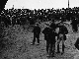Lincoln among the crowd at Gettysburg - November 19, 1863
December 8, 1863 - The President issues a Proclamation of Amnesty and Reconstruction for restoration of the Union.
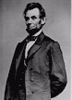 A Brady portrait - January 1864
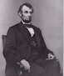 February, 1864 - Portrait later used as the basis for the Five Dollar Bill
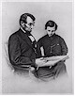 The President and son Thomas (Tad) - February 1864
March 12, 1864 - President Lincoln appoints Grant as General-in-Chief of all the Federal armies. William T. Sherman succeeds Grant as Commander in the West.
June 3, 1864 - A costly mistake by Grant results in 7,000 Union casualties in twenty minutes during an offensive against entrenched Confederates at Cold Harbor, Virginia.
June 8, 1864 - Abraham Lincoln is nominated for a second term as president by a coalition of Republicans and War Democrats.
July 18, 1864 - The President issues a call for 500,000 volunteers for military service.
August 31, 1864 - Makes a speech to the 148th Ohio Regiment.
September 2, 1864 - Atlanta is captured by Sherman's army. Later, the President on advice from Grant, approves Sherman's 'March to the Sea.'
October 19, 1864 - A decisive Union victory by General Philip H. Sheridan in the Shenandoah Valley.
November 8, 1864 - Abraham Lincoln is re-elected as President (age 55), defeating Democrat George B. McClellan. Lincoln gets 212 of 233 electoral votes and 55 percent of the popular vote.
December 20, 1864 - Sherman reaches Savannah in Georgia leaving behind a path of destruction 60 miles wide all the way from Atlanta.
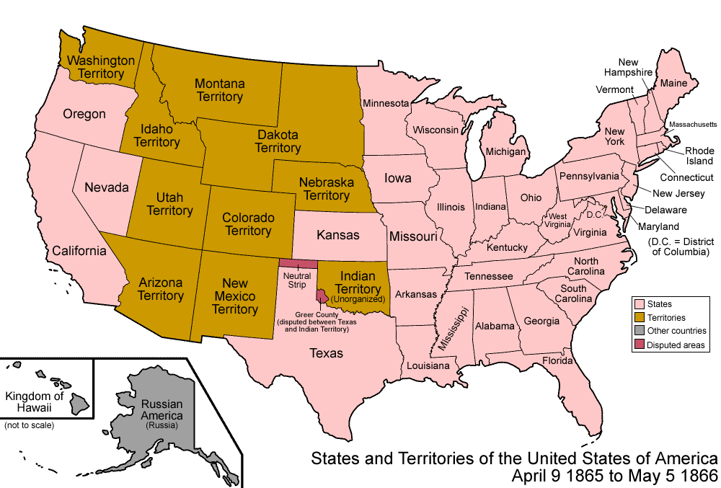
March 4, 1865 - Inauguration ceremonies in Washington, D.C. with President Lincoln delivering his Second Inaugural Address.
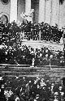Lincoln speaking at his Second Inauguration - March 4, 1865
March 17, 1865 - A kidnap plot by John Wilkes Booth fails when Lincoln doesn't arrive for a visit to the Soldiers' Home.
April 9, 1865 - The Civil War concludes as General Robert E. Lee surrenders his Confederate Army to General Ulysses S. Grant at the village of Appomattox Court House in Virginia.
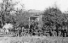Federal soldiers pose outside the court house - April 9, 1865
April 10, 1865 - Celebrations break out in Washington.
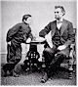The President's son Tad poses - April 10, 1865
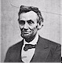Taken by Gardner - The last portrait - April 10, 1865
April 11, 1865 - President Lincoln makes his last public speech which focuses on the problems of reconstruction. The United States flag 'Stars and Stripes' is raised over Fort Sumter.
April 14, 1865 - Lincoln and his wife Mary see the play "Our American Cousin" at Ford's Theater. About 10:13 p.m., during the third act of the play, John Wilkes Booth shoots the President in the head. Doctors attend to the President in the theater then move him to a house across the street. He never regains consciousness.
April 15, 1865 - President Abraham Lincoln (age 56) dies at 7:22 in the morning.
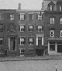The house in which President Lincoln died
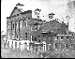Ford's Theater draped in black with guards posted - 1865
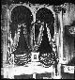The President's box at Ford's Theater - 1865
Funeral procession on Pennsylvania Avenue - April 19, 1865
April 26, 1865 - John Wilkes Booth is shot and killed in a tobacco barn in Virginia.
May 4, 1865 - Abraham Lincoln is laid to rest in Oak Ridge Cemetery, outside Springfield, Illinois.
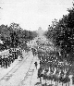A victory parade is held in Washington along Pennsylvania Ave. to help boost the Nation's morale - May 23-24, 1865.
December 6, 1865 - The Thirteenth Amendment to the United States Constitution, passed by Congress on January 31, 1865, is finally ratified. Slavery is abolished.

Bardo - Wikipedia
In some schools of Buddhism, bardo is an intermediate, transitional, or liminal state between death and rebirth. It is a concept which arose soon after the Buddha's passing, with a number of earlier Buddhist groups accepting the existence of such an intermediate state, while other schools rejected it. In Tibetan Buddhism, bardo is the central theme of the Bardo Thodol (literally Liberation Through Hearing During the Intermediate State), the Tibetan Book of the Dead. Used loosely, "bardo" is the state of existence intermediate between two lives on earth. According to Tibetan tradition, after death and before one's next birth, when one's consciousness is not connected with a physical body, one experiences a variety of phenomena. These usually follow a particular sequence of degeneration from, just after death, the clearest experiences of reality of which one is spiritually capable, and then proceeding to terrifying hallucinations that arise from the impulses of one's previous unskilful actions. For the prepared and appropriately trained individuals, the bardo offers a state of great opportunity for liberation, since transcendental insight may arise with the direct experience of reality; for others, it can become a place of danger as the karmically created hallucinations can impel one into a less than desirable rebirth. Metaphorically, bardo can describe times when our usual way of life becomes suspended, as, for example, during a period of illness or during a meditation retreat. Such times can prove fruitful for spiritual progress because external constraints diminish. However, they can also present challenges because our less skilful impulses may come to the foreground, just as in the sidpa bardo. The concept of antarabhāva, an intervening state between death and rebirth, was brought into Buddhism from the Vedic-Upanishadic philosophical tradition which later developed into Hinduism.
… Fremantle (2001: p. 53–54) charts the development of the bardo concept through the Himalayan tradition:
Originally bardo referred only to the period between one life and the next, and this is still its normal meaning when it is mentioned without any qualification. There was considerable dispute over this theory during the early centuries of Buddhism, with one side arguing that rebirth (or conception) follows immediately after death, and the other saying that there must be an interval between the two. With the rise of mahayana, belief in a transitional period prevailed. Later Buddhism expanded the whole concept to distinguish six or more similar states, covering the whole cycle of life, death, and rebirth. But it can also be interpreted as any transitional experience, any state that lies between two other states. Its original meaning, the experience of being between death and rebirth, is the prototype of the bardo experience, while the six traditional bardos show how the essential qualities of that experience are also present in other transitional periods. By refining even further the understanding of the essence of bardo, it can then be applied to every moment of existence. The present moment, the now, is a continual bardo, always suspended between the past and the future.
However, as shown above, Fremantle's idea that it was originally only "between one life and next" was not how it was understood by the Sarvāstivāda school at the outset. Also, the idea that the ascendancy of this idea was due to the Mahāyāna is unfounded, and it is much more likely that it was due to the Sarvāstivāda influence, several centuries before the Mahāyāna had any real influence.
Limbo - Wikipedia
In Catholic theology, Limbo (Latin limbus, edge or boundary, referring to the "edge" of Hell) is a speculative, non-scriptural idea about the afterlife condition of those who die in original sin without being assigned to the Hell of the Damned. Medieval theologians of western Europe described the underworld ("hell", "hades", "infernum") as divided into four distinct parts: Hell of the Damned,^{[2]} Purgatory, Limbo of the Fathers or Patriarchs, and Limbo of the Infants. However, Limbo of the Infants is not an official doctrine of the Catholic Church.

Christian Views on Hades /Church teachings - Wikipedia

The dead as conscious
Most mainstream Christian denominations and churches believe in some form of conscious existence after the death of the body.

Eastern Orthodox

The teaching of the Eastern Orthodox Church is that, "after the soul leaves the body, it journeys to the abode of the dead (Hades). There are exceptions, such as the Theotokos, who was borne by the angels directly into heaven. As for the rest, we must remain in this condition of waiting. Because some have a prevision of the glory to come and others foretaste their suffering, the state of waiting is called "Particular Judgment". When Christ returns, the soul rejoins its risen body to be judged by Him in the Last judgment. The 'good and faithful servant' will inherit eternal life, the unfaithful with the unbeliever will spend eternity in hell. Their sins and their unbelief will torture them as fire."

The Church of the East, Oriental Orthodoxy, the Eastern Orthodox Church and the Roman Catholic Church, hold that a final Universal Judgment will be pronounced on all human beings when soul and body are reunited in the resurrection of the dead. They also believe that the fate of those in the abode of the dead differs, even while awaiting resurrection: "The souls of the righteous are in light and rest, with a foretaste of eternal happiness; but the souls of the wicked are in a state the reverse of this."

Roman Catholic

The Latin word infernus or infernum (underworld) indicated the abode of the dead and so was used as the equivalent of the Greek word "ᾅδης" (hades). It appears in both the documents quoted above, and pointed more obviously than the Greek word to an existence beneath the earth. Later, the transliteration "hades" of the Greek word ceased to be used in Latin and "infernum" became the normal way of expressing the idea of Hades. Though "infernus" is usually translated into English as "hell", it did not have the narrow sense that the English word has now acquired. It continued to have the generic meaning of "abode of the dead". For the modern narrow sense the term "infernum damnatorum" (hell of the damned) was used, as in question 69, article 7 of the Supplement of the Summa Theologica of Thomas Aquinas, which distinguishes five states or abodes of the dead: paradise, hell of the damned, limbo of children, purgatory, and limbo of the Fathers: "The soul separated from the body is in the state of receiving good or evil for its merits; so that after death it is either in the state of receiving its final reward, or in the state of being hindered from receiving it. If it is in the state of receiving its final retribution, this happens in two ways: either in the respect of good, and then it is paradise; or in respect of evil, and thus as regards actual sin it is hell, and as regards original sin it is the limbo of children. On the other hand, if it be in the state where it is hindered from receiving its final reward, this is either on account of a defect of the person, and thus we have purgatory where souls are detained from receiving their reward at once on account of the sins they have committed, or else it is on account of a defect of nature, and thus we have the limbo of the Fathers, where the Fathers were detained from obtaining glory on account of the guilt of human nature which could not yet be expiated."^{[13]}

Anglican

The Anglican Catechist states that "there is an intermediate state between death and the resurrection, in which the soul does not sleep in unconsciousness, but exists in happiness or misery till the resurrection, when it shall be reunited to the body and receive its final reward." John Henry Hobart, an Anglican bishop, writes that "Hades, or the place of the dead, is represented as a spacious receptacle with gates, through which the dead enter." This space is divided into Paradise and Gehenna "but with an impassable gulf between the two". Souls, with exception of martyrs and saints, remain in Hades until the Final Judgment and "Christians may also improve in holiness after death during the middle state before the final judgment". As such, many Anglicans pray for the dead.

Methodist

In the Methodist Church, "hades denotes the intermediate state of souls between death and the general resurrection," which is divided into Paradise (for the righteous) and Gehenna (for the wicked). After the general judgment, hades will be abolished. John Wesley, the founder of Methodism, "made a distinction between hell (the receptacle of the damned) and hades (the receptacle of all separate spirits), and also between paradise (the antechamber of heaven) and heaven itself." The dead will remain in Hades "until the Day of Judgment when we will all be bodily resurrected and stand before Christ as our Judge. After the Judgment, the Righteous will go to their eternal reward in Heaven and the Accursed will depart to Hell (see Genesis 25)."

Reformed

John Calvin held that the intermediate state is conscious and that the wicked suffer in hell.

Greek Chorus - Wikipedia

A Greek chorus, or simply chorus (Greek: χορός, khoros) in the context of Ancient Greek tragedy, comedy, satyr plays, and modern works inspired by them, is a homogeneous, non-individualised group of performers, who comment with a collective voice on the dramatic action. The chorus consisted of between 12 and 50 players, who variously danced, sang or spoke their lines in unison and sometimes wore masks.
… Plays of the ancient Greek theatre always included a chorus that offered a variety of background and summary information to help the audience follow the performance. They commented on themes, and, as August Wilhelm Schlegel proposed in the early 19th century to subsequent controversy, demonstrated how the audience might react to the drama. According to Schlegel, the Chorus is "the ideal spectator", and conveys to the actual spectator "a lyrical and musical expression of his own emotions, and elevates him to the region of contemplation". In many of these plays, the chorus expressed to the audience what the main characters could not say, such as their hidden fears or secrets. The chorus often provided other characters with the insight they needed. Some historians argue that the chorus was itself considered to be an actor.

The chorus represents, on stage, the general population of the particular story, in sharp contrast with many of the themes of the ancient Greek plays which tended to be about individual heroes, gods, and goddesses. They were often the same sex as the main character. …
The chorus performed using several techniques, including singing, dancing, narrating, and acting. There is evidence that there were strong rhythmic components to their speaking.
They often communicated in song form, but sometimes spoke their lines in unison. The chorus had to work in unison to help explain the play as there were only one to three actors on stage who were already playing several parts each. As the Greek theatres were so large, the chorus' actions had to be exaggerated and their voices clear so that everyone could see and hear them. To do this, they used techniques such as synchronization, echo, ripple, physical theatre and the use of masks to aid them.

… Before the introduction of multiple, interacting actors by Aeschylus, the Greek chorus was the main performer in relation to a solitary actor. The importance of the chorus declined after the 5th century BCE, when the chorus began to be separated from the dramatic action. Later dramatists depended on the chorus less than their predecessors. As dialogue and characterization became more important, the chorus made less of an appearance. However, historian Alan Hughes argues that there was no such thing as decline, but rather the slow dissolution of one form into another: …

Lincoln in the Bardo

OUTLINE
  - Two parts of almost equal length — 176 and 164 pages respectively
  - Chapters 1 – 55 in Part 1; Chapters 56 – 108 in Part 2
  - Chapter numbering is in roman numerals (?)

From Showers of Hats, Robert Baird
“Every character we meet in the graveyard, save two (a nightwatchman and Abraham Lincoln) is recently dead. Convinced the coffins in which they spend the daylight hours are mere ‘sick-boxes’, and half-persuaded that they might recover into health at any moment, the ghosts are ‘tarrying’ in the near beyond. This grey purgatorial state is the ‘bardo’ of the novel’s title. It has little in common with the Buddhist concept of that name, which envisioned a sort of metempsychotic wormhole that connected successive cycles of rebirth. In Saunders’s bardo, a Dantean contrapasso transforms the ghosts in accordance with the moral ailments that afflicted their lives. Roger Bevins III, a young gay man who committed suicide, appears covered in eyes, noses and hands, a nod to the sensualist he became in the moments after he slit his wrists. A printer called Hans Vollman, killed by a falling roof beam hours before he planned to bed his young bride for the first time, is rewarded with a dented forehead and enormous erection. What awaits the spirits, once they work up the nerve to abandon their attachment to their former lives, is a confrontation with a mysterious ‘matterlightblooming phenomenon’, which escorts them to a terrifying final judgment.
The Lincoln of the title is not Abe but Willie, the president’s 11-year-old son, who dies of typhoid just hours before the novel begins. Like most of the ghosts, he is at first unaware of his own demise, and resolves to wait for his father to find him at the cemetery. This resolution gives the plot the kick it needs, as Willie’s determination runs up against a gruesome quirk of his new existence: children who tarry risk being trapped in the bardo for ever. To escape this fate, Willie must choose to yield to the matterlightblooming phenomenon, but that means accepting his separation from his father, and thus the reality of his own death.”
(Spliced within the central narrative is a second, composed of passages from real and invented historical sources, that describes the life of the Lincolns in the days just before and after their tragedy.)

TIMELINE

The main action of the book takes place on a single night in February 1862—February 25th. But the telling of the story occurs in the near past.

SETTING

The main action takes place in Washington DC’s Oak Hill Cemetery

CHARACTERS

While Willie is, with his father, the hero of his story, it is Bevins, Vollman and a preacher called Everly Thomas who deliver most of the lines. Joining these three are a throng of shades – each ‘wronged Neglected Overlooked Misunderstood’, as Willie puts it – who are eager to retail their own stories of woe. This is a ghost story, in other words, narrated by the ghosts.

BOOK REVIEWS

Showers of Hats, Robert Baird
George Saunders has long had a thing for ghosts, especially ghosts who haven’t figured out that they’re dead. The title story of his first collection, CivilWarLand in Bad Decline (1996), concerned a down-on-its-luck theme park with a Blacksmith Shoppe, a ninety-foot section of the Erie Canal, and a holographic projection of Jefferson Davis, president of the Confederate States. It also featured a family of dead homesteaders who carry on reading and doing their laundry as though it were still 1865. In ‘CommComm’, published in the New Yorker in 2003, a murdered couple unwittingly haunt their surviving son. No longer hungry, unable to pick up a fork or pee, they are baffled by their posthumous condition. ‘Something’s off but I don’t know what,’ the father says. That line could stand as a shorthand description of much of Saunders’s fiction, which, over twenty years and four collections, has often revelled in a sense of uncanny disorientation. But it seems especially fitting for Lincoln in the Bardo, his first novel, a polyphonic arrangement narrated by a chorus of ghosts who don’t know they’re ghosts.
The main action of the book takes place on a single night in February 1862, in Washington DC’s Oak Hill Cemetery. Every character we meet in the graveyard, save two (a nightwatchman and Abraham Lincoln) is recently dead. Convinced the coffins in which they spend the daylight hours are mere ‘sick-boxes’, and half-persuaded that they might recover into health at any moment, the ghosts are ‘tarrying’ in the near beyond. This grey purgatorial state is the ‘bardo’ of the novel’s title. It has little in common with the Buddhist concept of that name, which envisioned a sort of metempsychotic wormhole that connected successive cycles of rebirth. In Saunders’s bardo, a Dantean contrapasso transforms the ghosts in accordance with the moral ailments that afflicted their lives. Roger Bevins III, a young gay man who committed suicide, appears covered in eyes, noses and hands, a nod to the sensualist he became in the moments after he slit his wrists. A printer called Hans Vollman, killed by a falling roof beam hours before he planned to bed his young bride for the first time, is rewarded with a dented forehead and enormous erection. What awaits the spirits, once they work up the nerve to abandon their attachment to their former lives, is a confrontation with a mysterious ‘matterlightblooming phenomenon’, which escorts them to a terrifying final judgment.
The Lincoln of the title is not Abe but Willie, the president’s 11-year-old son, who dies of typhoid just hours before the novel begins. Like most of the ghosts, he is at first unaware of his own demise, and resolves to wait for his father to find him at the cemetery. This resolution gives the plot the kick it needs, as Willie’s determination runs up against a gruesome quirk of his new existence: children who tarry risk being trapped in the bardo for ever. To escape this fate, Willie must choose to yield to the matterlightblooming phenomenon, but that means accepting his separation from his father, and thus the reality of his own death.
Willie is only one of the narrators of his tale, which reads less like a traditional novel than a script for screen or stage. (Spliced within the central narrative is a second, composed of passages from real and invented historical sources, that describes the life of the Lincolns in the days just before and after their tragedy.) But while Willie is, with his father, the hero of his story, it is Bevins, Vollman and a preacher called Everly Thomas who deliver most of the lines. Joining these three are a throng of shades – each ‘wronged Neglected Overlooked Misunderstood’, as Willie puts it – who are eager to retail their own stories of woe. This is a ghost story, in other words, narrated by the ghosts.
In the early part of his career, Saunders was celebrated mostly as a satirist. He trained as a petrochemical engineer, and wrote his earliest published stories while working as a technical writer in upstate New York. The experience left him on intimate terms with the microhumiliations of white-collar drudge work. Years before The Office mined the same seam, Saunders identified the specific perversity of the modern corporation, which demands not just work from its employees but loyalty and affection – even something like love. Unlike Ricky Gervais, however, who hitched his on-screen satires to a realistic setting, Saunders translated his stories out into the near future, or over into cockeyed alternative versions of the present. His stories were filled with perverted theme parks, creepy testing facilities and grungy sci-fi conceits, all rendered in a hypercolloquial idiolect that set the chipper barbarities of capitalism in scathing relief.
When CivilWarLand appeared, in the mid-1990s, it was quickly swept up into one of America’s rare and mysterious revolutions in sentiment. A broad insurgency of irony was rising up in just about every medium – The Simpsons, the Baffler, Pulp Fiction – against the schmaltz that had ruled the country’s mass culture for decades. But even then it was obvious that Saunders wasn’t interested in snark for snark’s sake. Jay McInerney, reviewing CivilWarLand for the New York Times, recognised him as ‘one of those rare writers who can effortlessly blend satire and sentiment’. The shape of that sentiment became increasingly clear. In a eulogy for David Foster Wallace, who killed himself in 2008, Saunders explained his friend’s accomplishment in terms that made it hard not to imagine he was also describing his own aspirations: ‘Something about the prose itself was inducing a special variety of openness that I might call terrified-tenderness: a sudden new awareness of what a fix we’re in on this earth, stuck in these bodies, with these minds.’ To say that Saunders sought empathy in a world that seemed hostile to it wasn’t to say that he went in for easy uplift and happy endings: the poor in his stories got poorer, the cruelties of the universe were compounded, and not even death offered much of a reprieve. Many of his protagonists aren’t kind or even objectively decent human beings, but they are, in a strict sense, sympathetic: Saunders lets us overhear their rationalisations, their excuses, the stories they tell themselves to live. The goal, as he described it in an interview last year, was to create ‘a space the reader and writer agree to participate in together, within the playing field of a work of prose – in which they agree to make up a person and, together, go: “What would it be like to be her? How does she think? From what valid impulse do her mistakes stem?”’
In retrospect, the most striking thing about this focus on compassion was the way it accompanied – and even hastened – a growing consensus in American literary circles that saw empathy as fiction’s remaining credible raison d’être. For Saunders, as for Wallace, fiction’s task among the arts was to offer an answer to the problem of other minds. ‘The prime quality of literary prose – that is, the thing it does better than any other form (movies, songs, sculpture, tweets, television, you name it) – is voice,’ Saunders wrote recently. ‘A great writer mimicking, on the page, the dynamic energy of human thought is about as close as we can get to modelling pure empathy.’ Saunders’s reputation grew to the point that in 2013 a profile in the New York Times Magazine called him ‘a kind of superhero’. What was surprising wasn’t so much the suggestion that he was ‘the writer for our time’ – it would be hard to overstate his influence on American writing – but the terms on which the claim was established. According to the profile, Saunders had ascended to the first rank of American fiction because he helped his readers be ‘wiser, better, more disciplined in [their] openness to the experience of other people’.
And yet for all this emphasis on what one critic called Saunders’s ‘humane ethics’, the stories themselves remained as giddily inventive as ever. In ‘The Semplica Girl Diaries’, from his most recent collection, Tenth of December (2014), a man desperate to impress his daughter leases a set of live human lawn ornaments, who are strung up by an intercranial wire that holds their feet a few inches off the grass. In ‘Escape from Spiderhead’, from the same book, an intravenous drip of an experimental drug called ED289/290 prompts ‘transcendently stupefying’ bouts of lovemaking. Both stories solicit our empathy, but also remain faithful to the strange worlds of his own imagining.
‘The probability is high that there is a vast reality that we have no way to perceive, that’s actually bearing down on us now and influencing everything,’ Saunders said in the Times Magazine profile, which appeared after he’d already begun work on Lincoln in the Bardo. ‘The idea of saying, “Well, we can’t see it, therefore we don’t need to see it,” seems really weird to me.’ I don’t doubt that Saunders’s existential attraction to the ghost-story form is sincere. And yet it seems obvious that the post-mortem set-up of the novel also offered him a useful way to channel his antic energies. It’s only barely hyperbole to say that every minute of Lincoln’s every day in office has been written about by someone, somewhere, cluttering the trail of a would-be dramatist with hundreds of hard and implacable facts. By restricting the main action of his novel to a single night, and setting it mostly among the dead in Oak Hill Cemetery, Saunders is able to slip the straitjacket of historical fiction.
What’s more, the ghosts of the bardo offer a comic counterweight to the Lincolns’ shared grief. Besides Vollman, Bevins and Thomas, we meet Eddie and Betsy Baron, a poor, dirty couple who can barely speak a sentence without expletives; Jane Ellis, whose three daughters appear in ‘gelatinous orbs floating about her person’; and the Bachelors, a trio of young men who drift overhead, dispensing showers of hats. Irritable, sarcastic and often ridiculous, the ghosts joke and jibe at one another’s expense.
There are times when the novel seems too intent on mere entertainment, as though we can’t be trusted to manage its heavier moods without a little tap dancing to carry us through. You see this at the end of the novel, when, out of nowhere, Saunders stages a spectral ménage à quatre. You see it, too, in the middle of the book, when an earnest disquisition by Reverend Everly is interrupted by Vollman rolling a pebble down his extended penis. And you see it even in the novel’s second sentence, when Vollman describes his marriage at 46 to an 18-year-old wife: ‘I know what you are thinking,’ Vollman tells us. ‘Older man (not thin, somewhat bald, lame in one leg, teeth of wood), exercises the marital prerogative.’ But no, he assures us: ‘That is exactly what I refused to do.’ Vollman decided unilaterally to refrain from sex, he says, at least until his wife pleads with him to ‘expand the frontiers of our happiness together in that intimate way to which I am, as yet, a stranger’. Forget for a moment the strangeness of a scruple that finds its red line somewhere between marriage and the marriage bed. (Yes, John Ruskin, but this, we’re given to understand, was Vollman’s second wife.) What’s really odd is Vollman’s need to explain a 19th-century wedding in terms meant to flatter a 21st-century sensibility. When Vollman says: ‘I know what you are thinking,’ he’s not only coddling his young wife – he’s also (with his author behind him) coddling us.
Every metaphysics encodes a moral vision, and Saunders’s bardo is no exception. For the most part the sins that shape the bardo’s structure are recognisably Buddhist: an attachment to the things of this world, an insistence on one’s own ego, an inability to recognise the suffering at the core of every person. The most distinctive feature of his ghost-world, however, is a phenomenon the Oak Hill ghosts approach with some trepidation. By superimposing themselves on a living human, they are able to experience the thoughts, feelings and memories of their host. Through the same means they are also able to share one another’s thoughts, as Bevins and Vollman discover when they occupy Lincoln at the same time. The effect, for the ghosts, is ‘an astonishment’. It stands, too, of course, as a literal instantiation of what Saunders once claimed was ‘what all fiction does, really, or tries to do – encourages us to step out of ourselves and into someone else, temporarily’. Empathy-by-haunting is also the way that we, and Willie, come to know the specific contours of the elder Lincoln’s grief. The first time Willie tries it, in the moments after his father has removed his corpse from its coffin to hold it close, he tells us he ‘could feel the way his long legs lay How it is to have a beard Taste coffee in the mouth.’ He hears his father consoling himself: ‘The feel of him in my arms has done me good. It has. Is this wrong? Unholy? No, no, he is mine, he is ours, and therefore I must be, in that sense, a god in this; where he is concerned I may decide what is best. And I believe this has done me good. I remember him. Again.’
The encounters between Willie and his father are some of the most affecting scenes in the novel. But they also set the stage for the book’s central conundrum. Contemplating his son’s death, the president considers a familiar complaint: ‘What put out that spark? What a sin it would be. Who would dare. Ruin such a marvel. Hence is murder anathema. God forbid I should ever commit such a grievous –’.
The sentiment is cut short, according to Vollman, who reports these thoughts from inside Lincoln’s head, by ‘a notion just arising’. The next chapter, a quasi-historical collage, makes plain what that means. The first snippet in the chapter tells us that ‘young Willie Lincoln was laid to rest on the day that the casualty lists from the Union victory at Fort Donelson were publicly posted.’ The lists were a shock to the public, ‘the cost in life being unprecedented thus far in the war’. So far the story has been a more or less local affair, a smallish tale about a graveyard of cranky ghosts and a grieving father and son who might, given new clothes and a new vocabulary, have been anyone. But now Saunders brings this minor drama into juxtaposition with the major war to which Lincoln committed his broken nation. And in the crux of this conjunction we can sense Saunders testing himself – testing what appear to be his own most cherished notions about the way the world works. Take his premise that every person on earth is in sorrow and suffering, and put it beside the conclusion that ‘therefore one must do what one could to lighten the load of those with whom one came into contact.’ What then the excuse for a righteous civil war?
Saunders doesn’t duck this dilemma, even if, in the end, his attempt to square the circle is one of the least persuasive aspects of his book. His Lincoln can defend the war as a means to ‘end suffering by causing more suffering’, as a defence of the American democratic ideal, and even as a satisfaction of a mysterious divine bloodlust, but he appears philosophically incapable of the view, expressed by the real Lincoln in his Second Inaugural, that divine justice might demand war as recompense for ‘every drop of blood drawn with the lash’ and ‘the bond-man’s two hundred and fifty years of unrequited toil’. The nearest thing the novel allows to the Second Inaugural’s ‘firmness in the right as God gives us to see the right’ comes late in the book, after a grand spectacle in which all the ghosts in the cemetery pile into Lincoln, like something from Whitman or the frontispiece to Hobbes’s Leviathan. As Lincoln leaves a chapel near the graveyard, he passes through the soul of a former slave called Thomas Havens, who catches his pace and walks with him for a while. Havens’s exhilaration at the sense of freedom initially strikes an off note; we wonder what penitential scheme could possibly see fit to keep a slave in bondage after his death. But eventually he exhorts the president to ‘do something for us, so that we might do something for ourselves.’ For once in this book, however late and however quietly, we are reminded that not all suffering is equal, not all loads equally deserving of reprieve.

My thoughts on the book

- The impossibility of getting history right – even contemporaneous reports don’t match up – e.g. Chapter 5 —p19 “In several accounts of the evening, the brilliance of the moon is remarked upon. … / There was no moon that night and the sky was heavy with clouds.”

- Reconciling Lincoln the man and Lincoln the myth – Reconciling the personal and public lives of political leaders generally

Honouring a freedom fighter, Barbara Kay, National Post, June 6, 2018
“In this country, former leaders’ lives are scrutinized through the moral equivalent of the Hubble Space Telescope to find nano-scale thought rubble. We have seen statuary removed and names erased from institutions for past sins not considered sins in their era. Indeed, Canada’s own father of Confederation, John A. Macdonald, once an obvious, uncontested choice for institutional affiliation, suffered this reversal of fortune for his linkage to Indigenous residential schools.
And so, one might say it is now an act of supreme optimism to immortalize even a beloved national founder’s name in a public park.”
- Phantasmagoria in art — Saunders and Bosch?

Phantasmagoria | Define Phantasmagoria at Dictionary.com –
a shifting series of phantasms, illusions, or deceptive appearances, as in a dream or as created by the imagination. a changing scene made up of many elements. an optical illusion produced by a magic lantern or the like in which figures increase or diminish in size, pass into each other, dissolve, etc.
phantasmagoria (plural phantasmagorias) – Wikipedia
- A popular 18th- and 19th-century form of theatre entertainment whereby ghostly apparitions are formed; a magic lantern.
- A series of events involving rapid changes in light intensity and colour.
- A dreamlike state where real and imagined elements are blurred together.
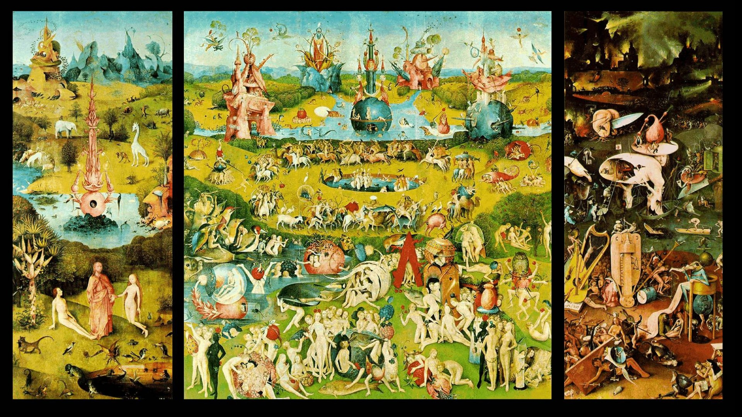
The Garden of Earthly Delights is the modern title given to a triptych oil painting on oak panel painted by the Early Netherlandish master Hieronymus Bosch, housed in the Museo del Prado in Madrid since 1939. It dates from between 1490 and 1510, when Bosch was between 40 and 60 years old.
As so little is known of Bosch's life or intentions, interpretations of his intent have ranged from an admonition of worldly fleshy indulgence, to a dire warning on the perils of life's temptations, to an evocation of ultimate sexual joy. The intricacy of its symbolism, particularly that of the central panel, has led to a wide range of scholarly interpretations over the centuries. Twentieth-century art historians are divided as to whether the triptych's central panel is a moral warning or a panorama of paradise lost. Peter S. Beagle describes it as an "erotic derangement that turns us all into voyeurs, a place filled with the intoxicating air of perfect liberty".
Bosch painted three large triptychs (the others are The Last Judgment of c. 1482 and The Haywain Triptych of c. 1516) that can be read from left to right and in which each panel was essential to the meaning of the whole. Each of these three works presents distinct yet linked themes addressing history and faith. Triptychs from this period were generally intended to be read sequentially, the left and right panels often portraying Eden and the Last Judgment respectively, while the main subject was contained in the center piece. It is not known whether The Garden was intended as an altarpiece, but the general view is that the extreme subject matter of the inner center and right panels make it unlikely that it was intended to function in a church or monastery, but was instead commissioned by a lay patron.

- The voices of this book – the archivist and the ghosts (a Greek chorus?) — sympathy/empathy?
Contrast with the traditional Greek chorus
- Not a homogeneous group,
- An individualised group of performers
- Do not speak in unison

BUT

- They do comment on the dramatic action.
- There are between 12 and 50 players, who variously move about and speak their lines
- Costumed
- Offer a variety of background and summary information to help the audience follow the main story
- Comment on themes, and demonstrate how the reader/audience might react to the main story

- Why this story now, told in this way? — Slavery as America’s irredeemable original sin?

irredeemable —impossible to correct, improve, or change
idioms
a leopard can't/doesn't change its spots, no hard and fast rules, burn your boats/bridges, what's done is done
synonyms
congenital, continuity, fixity, hard line, hard-liner, immutable, incurable, irremediable, irreparable, irretrievable, irreversible, irrevocable, ossify, unchangeable, uncompromising

